Project Development Phase

Date

Team ID

Project Name
( Sprint – 2 )

5 November 2022

PNT2022TMID14815

PERSONAL ASSISTANCE FOR SENIORS WHO ARE SELF-
RELIANT

Text To Speech Service:
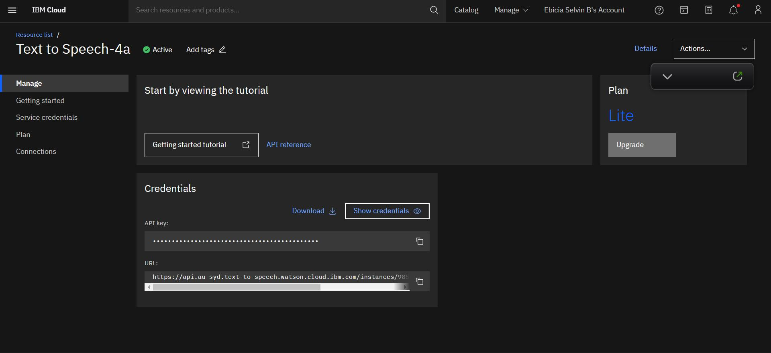

( API Created ! )
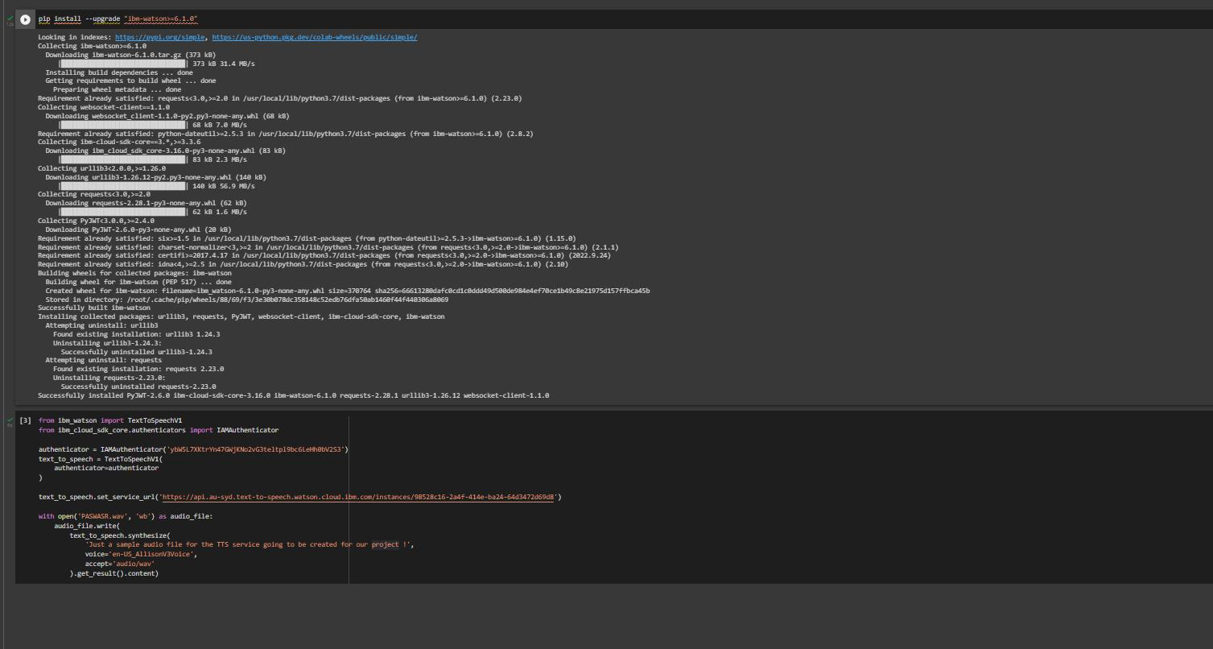

( Created Using Colab !! )

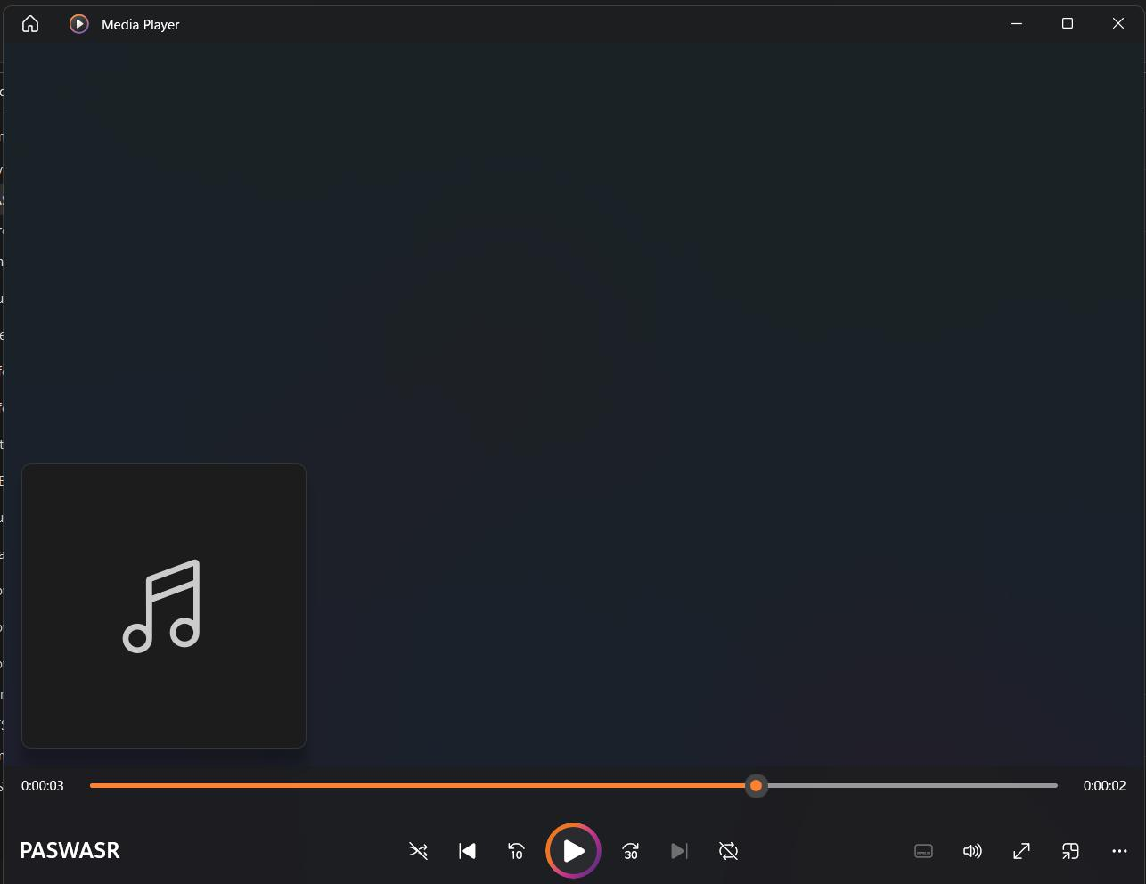

->A Sample Audio On How Medicine Names Given By User Will Be Delivered..

Creation Cloudant DB :
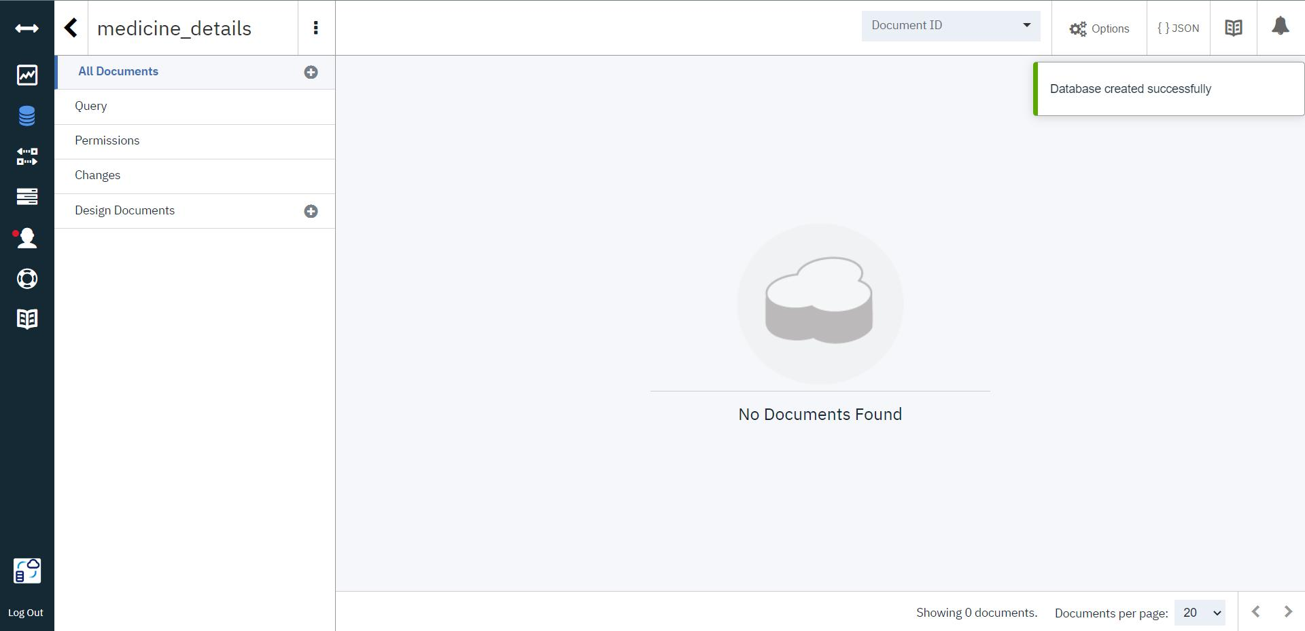

( Database Named “medicine_details” have been created.. )

